



**A CRM APPLICATION TO ENGINEERING WORKS**

# Project Overview

# This project is focused on Engineering Project Management System (EPMS), designed to address the challenges of managing client information, project details, and pricing calculations in engineering works. The goal is to deliver a comprehensive solution by leveraging a user-friendly web application built on modern technologies such as salesforce setup menu, we aim to enhance operational efficiency and data accuracy while providing a seamless user experience for project managers, clients, and workers. This system will support the long-term goals of engineering firms and project management departments by streamlining workflows, improving communication, and ensuring timely project delivery

# 2. Objectives



**Business Goals:**

**Increase Project Efficiency:**

Reduce project completion time by 20% within the first year of implementation by streamlining project management processes.

**Enhance Client Satisfaction:**

Achieve a client satisfaction score of 90% or higher through improved communication and timely project updates.

**Improve Cost Management:**

Decrease project cost overruns by 15% by providing accurate pricing calculations and material tracking.

**Boost Worker Productivity:**

Increase worker productivity by 25% by effectively assigning tasks and tracking progress in real-time.

**Expand Client Base:**

Increase the number of active clients by 30% within the first two years by offering enhanced services and improved project management capabilities.

**Specific Outcomes:**

**User -Friendly Interface:**

Develop a responsive web application with an intuitive user interface that allows users to easily navigate through client, project, and material management features.

**Comprehensive Client Database:**



Create a centralized database to store and manage client information, including company details, owner information, and contact details, with a target of having 100% of existing clients migrated to the new system within six months

**Automated Pricing Calculation:**

Implement an automated pricing calculation feature that accurately computes costs based on materials and measurements, reducing manual errors by 90%.

**Project Tracking Dashboard:**

Develop a real-time project tracking dashboard that provides insights into project status, worker assignments, and material usage, with a goal of 100% visibility for project managers.

**Reporting and Analytics:**

Generate comprehensive reports on project performance, costs, and resource allocation, with at least 5 different report templates available for users by the end of the first year.

**Integration with Existing Tools:**

Ensure seamless integration with existing tools and software used by the organization (e.g., accounting software, communication platforms) to enhance workflow efficiency.

**Training and Support:**

Provide training sessions for all users, aiming for at least 90% of staff to be proficient in using the new system within three months of launch.

**Feedback Mechanism:**



Establish a feedback mechanism to gather user input and continuously improve the system, with a target of implementing at least 3 major updates based on user feedback within the first year.

By achieving these goals and outcomes, the EPMS will significantly enhance the management of engineering projects, leading to improved operational efficiency and client satisfaction3. Salesforce Key Features and Concepts Utilize

**3. Salesforce Key Features and Concepts Utilized**

**1. Sales Cloud:**

**Lead and Opportunity Management:** Tools for tracking potential customers and sales opportunities, including lead scoring and opportunity pipelines.

**Sales Forecasting:** Features for predicting sales revenue and tracking performance against sales targets.

1. **Service Cloud**

**Case Management:** Allows support teams to track and resolve customer issues efficiently.

**Knowledge Base:** A centralized repository for articles and FAQs to help customers and support agents find answers quickly.

1. **Marketing Cloud**



**Email Marketing:** Tools for creating and managing email campaigns, including automation and personalization features.

**Customer Journey Mapping:** Visual representation of the customer’s interactions with the brand, allowing for tailored marketing efforts.

# 4. Community Cloud

# Customer Communities: Platforms for customers to interact with each other and the company, facilitating peer support and engagement.

# Partner Portals: Secure access for business partners to collaborate and share information.

# 5. Analytics and Reporting

# Dashboards: Customizable visual displays of key metrics and performance indicators.

# Reports: Detailed analyses of data, allowing users to filter and segment information for deeper insights.

# 6. Automation Tools

# Process Builder: A point-and-click tool for automating business processes without code.

# Workflow Rules: Automated actions triggered by specific criteria, such as sending alerts or updating records

**7. AppExchange**

**Third-Party Integrations:** Access to a marketplace of applications that can extend Salesforce’s capabilities, including industry-specific solutions.

**8. Custom Objects and Fields**



**Custom Data Models:** Ability to create custom objects and fields to meet unique business requirements and data structures.

**9. Security and Access Control**

**Profiles and Permission Sets:** Tools for managing user access and permissions, ensuring data security and compliance.

**Role Hierarchies:** Structure that defines data visibility and access based on organizational roles

# 3. Detailed Steps to Solution Design



# 1. Data Models

# 1.1. Entity Relationship Diagram (ERD)

# 

# 



# Entities:

# Client:

# Client ID (Primary Key)

# Company Name

# Owner Name

# Contact Number

# Email Address

# Project:

# Project ID (Primary Key)

# Client ID (Foreign Key)

# Project Type (Fabrication, Shed Construction, Pipe Lining)

# Project Description

# Start Date

# End Date

# Worker:

# Worker ID (Primary Key)

# Worker Name

# Worker Role

# Contact Info

# Project ID (Foreign Key)

# Material:



# Material ID (Primary Key)

# Material Name

# Unit Price

# Measurement Unit

# Material Requirement

# Requirement ID (Primary Key)

# Project ID (Foreign Key)

# Material ID (Foreign Key)

# Quantity:

# Total Price (Calculated Field)

# Process:

# Process ID (Primary Key)

# Process Name (Drilling, Welding, Cutting, Folding, etc.)

# Project ID (Foreign Key)

# Status (Not Started, In Progress, Completed)

1. **User Interface Designs:**



# Fabrications:

To create various fields in the "Fabrication" object in Salesforce, begin by navigating to Setup and selecting Object Manager, then search for and click on the "Fabrication" object. In the "Fields & Relationships" section, click "New" to start creating fields. Begin with a Text field labeled "Name of the Owner," ensuring it's required and has a length of 125. Next, create another Text field for "Name of Company." Follow this with three Number fields for "Length," "Breadth," and "Width," each with a length of 16, two decimal places, and marked as required. Then, add a Formula field for "Area" that calculates the product of Length, Breadth, and Width. Create a Number field for "Cost per Meter" with a default value of 2 and set it as read-only. Proceed to add a Number field for "Quantity," also required, and then a Formula field for "Amount" that computes the total based on Area, Cost per Meter, and Quantity. Next, create a Picklist field for "Material Type" with options like Iron and Steel, followed by a Currency field for "Final Price." Finally, add an Email field for capturing email addresses. After filling in the necessary details for each field, click "Next" and "Save" to complete the process

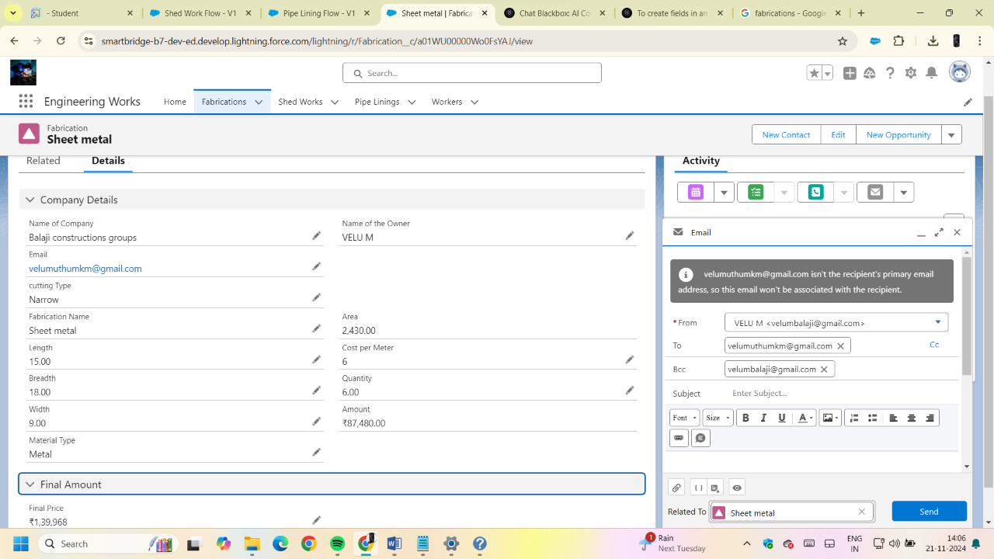

# 



# Shed – Works:

To create fields in the "Shed-Work" object in Salesforce, start by accessing the Object Manager from Setup and locating the "Shed-Work" object. In the "Fields & Relationships" section, click "New" to create fields. First, add a Text field for "Name of the Company," ensuring it is required. Next, create another Text field for "Name of the Owner." Then, add three Number fields for "Height," "Breadth," and "Width," each with a length of 16, two decimal places, and marked as required. Following that, create two Formula fields: one for "Area" that calculates the volume using Height, Breadth, and Width, and another for "Area Sheet" that calculates the area using Height and Breadth. Add a Number field for "Cost per Meter" with a default value of 2, set to read-only, and another for "Quantity," also required. Next, create a Number field for "Cost per Meter Sheet," again with a default value of 2 and set to read-only. Then, add a Formula field for "Amount" that computes the total based on Area, Cost per Meter, and Quantity, and another for "Amount Sheet" based on Cost per Meter Sheet, Area Sheet, and Quantity. Create two Picklist fields for "Material Type" (with options like Iron, Metal, Steel) and "Material Type Sheet" (with options like Plastic, Metal, Rubber). Finally, add a Currency field for "Final Price" and an Email field for capturing email addresses. Each field creation step involves filling in specific details and clicking through the prompts to save the fields



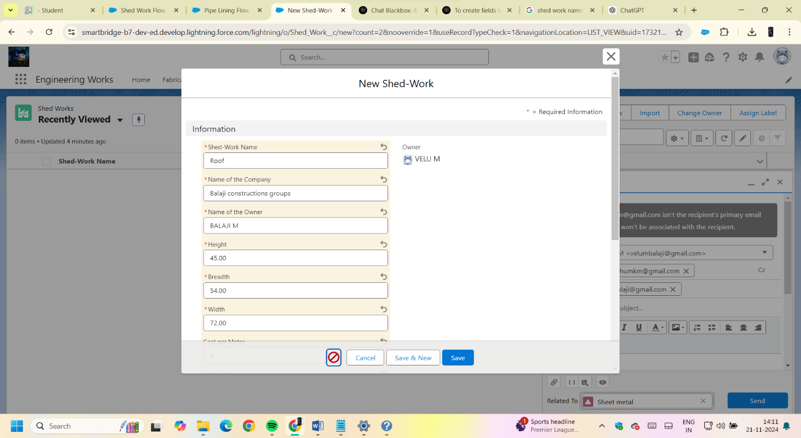

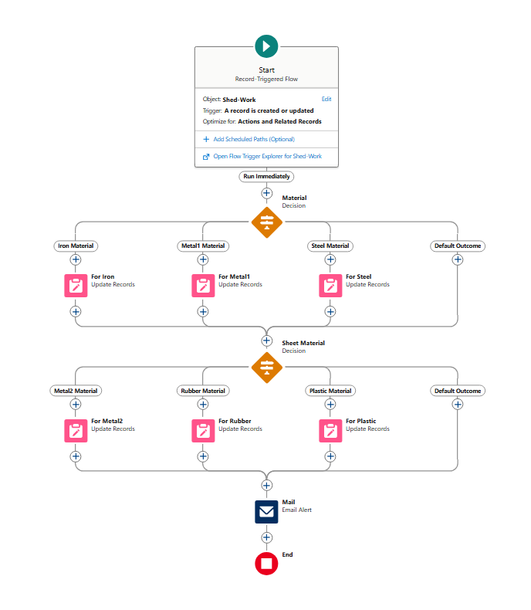





1. **Pipe lining works:**

To create fields in the "Pipe Lining" object in Salesforce, start by accessing the Object Manager through Setup and searching for "Pipe Lining." In the "Fields & Relationships" section, click "New" to add fields. Begin by creating a required Text field for "Name of the Company" and another required Text field for "Name of the Owner." Next, add three required Number fields: "Height," "Width," and "Diameter," each with a length of 16 and two decimal places. Then, create a Formula field for "Area" that calculates the area using the formula ( \text{PI()} \times \text{Height} \times \text{Diameter} ). Following that, add a Number field for "Cost per Meter" with a default value of 2, set to read-only, and another required Number field for "Quantity." Next, create a Formula field for "Amount" that calculates the total based on Area, Cost per Meter, and Quantity. Then, add a Picklist field for "Material Type" with options like Iron, Metal, and Aluminium. After that, create a Currency field for "Final Price" and an Email field for capturing email addresses. Each step involves filling in specific details and saving the fields to enhance the functionality of the "Pipe Lining" object

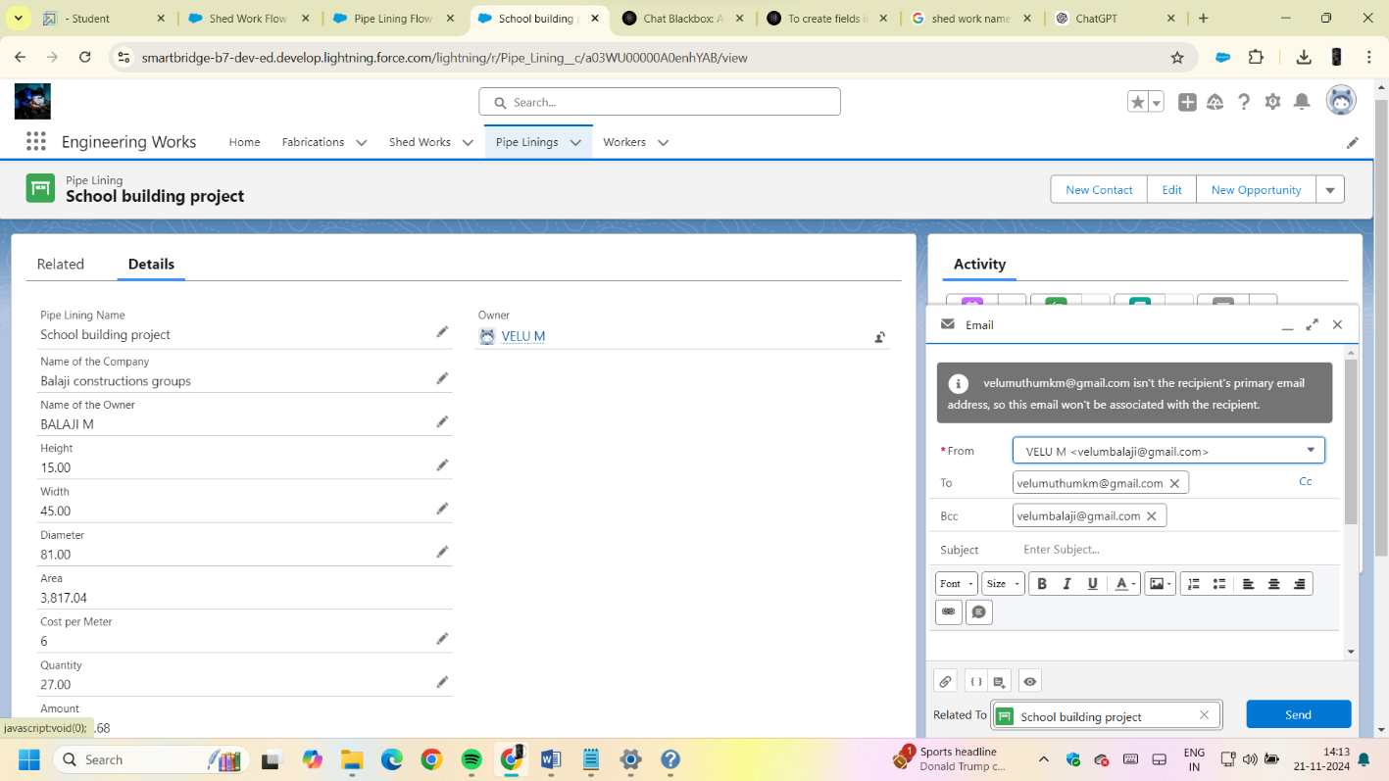

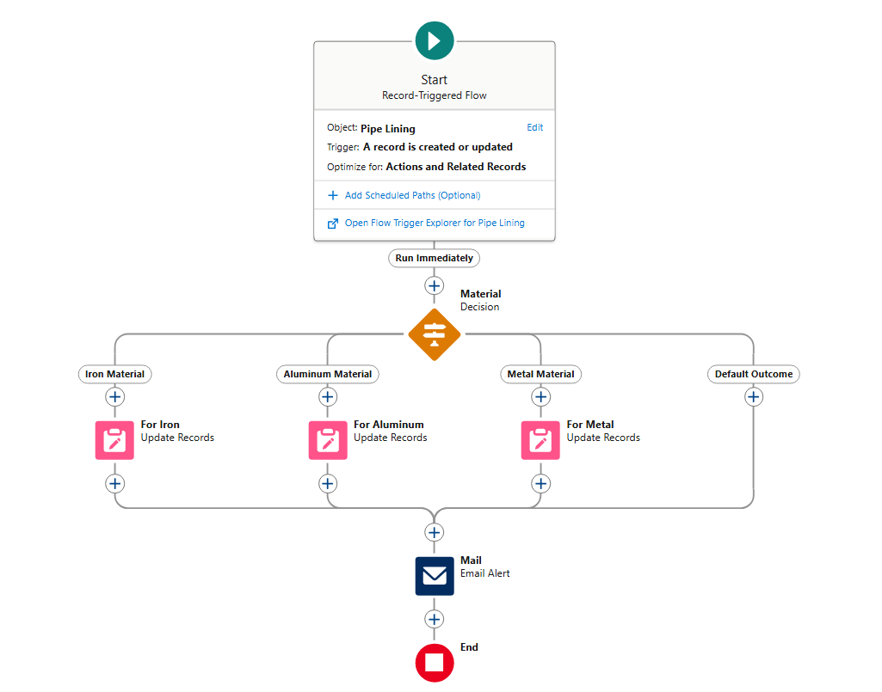



1. **Workers:**

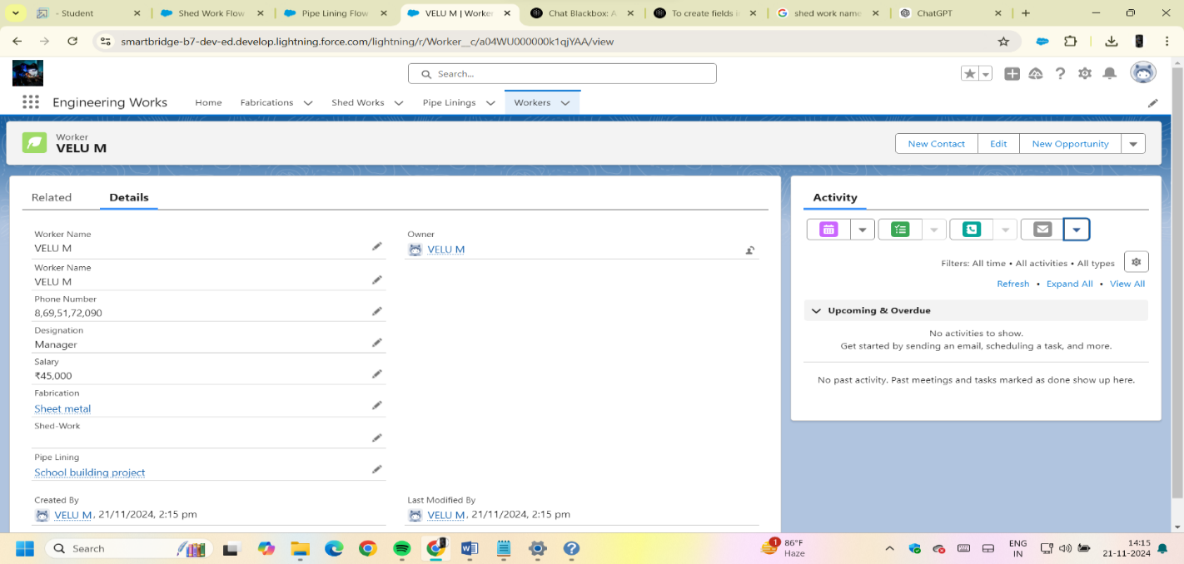 To create fields in the "Worker" object in Salesforce, start by accessing the Object Manager from Setup and searching for the "Worker" object. In the "Fields & Relationships" section, click "New" to add fields. First, create a Text field labeled "Worker Name," with an auto-generated field name and a length of 125 characters. Next, add a required Number field for "Phone Number," specifying a field name of "Phone_Number" with a length of 10. Then, create a Picklist field titled "Designation," entering options such as Accountant, Welder, Driller, Pitter, and Manager. Finally, add a required Currency field labeled "Salary," with a field name of "Salary" and a length of 10. Each step requires filling in specific details and saving the fields, thereby enhancing the functionality and data management capabilities of the "Worker" object

**3. Business Logic**



**3.1. Price Calculation Logic**

When a material requirement is added, the application will automatically calculate the total price using the formula: [ **\text{Total Price} = \text{Unit Price} \times \text{Quantity}** ]

**3.2. Process Management Logic**

Each project will have a workflow that tracks the status of each process (e.g., Not Started, In Progress, Completed). The application will allow updates to the status of each process.

**3.3. Notifications and Alerts**

The application can send notifications or alerts for:

Upcoming deadlines for project completion.

Changes in project status.

Material shortages.

# Testing and Validation



1. **Test Planning**

**Define Objectives:** Establish clear testing objectives aligned with business requirements.

**Identify Test Cases:** Create detailed test cases that cover all functionalities, including standard and custom objects, workflows, integrations, and reports.

Determine Testing Types: Decide on the types of testing to be performed, such as unit testing, integration testing, user acceptance testing (UAT), and performance testing.

1. **Unit Testing**

**Component Testing:** Test individual components (such as Apex classes, triggers, and Visualforce pages) to ensure they function correctly in isolation.

**Validation of Business Logic:** Ensure that any custom business logic implemented through code behaves as expected under various conditions.

1. **Integration Testing**

**End-to-End Testing:** Validate the integration points between Salesforce and other systems (e.g., ERP, marketing automation tools) to ensure data flows correctly and processes work seamlessly.

**Error Handling:** Test how the system responds to errors or data discrepancies during integration.

1. **User Acceptance Testing (UAT)**



**Involve End Users:** Engage a group of end users to validate the system against business requirements and real-world scenarios.

**Feedback Loop:** Collect feedback from users on usability, functionality, and any issues encountered during testing. Make necessary adjustments based on this feedback.

1. **Performance Testing**

**Load Testing:** Assess how the system performs under varying loads to ensure it can handle peak usage without degradation in performance.

Response Time Testing: Measure the response times for key transactions to ensure they meet acceptable thresholds.

1. **Regression Testing**

**Post-Changes Testing:** After any changes, such as bug fixes or new features, conduct regression testing to ensure existing functionalities are not adversely affected.

**Automated Testing Tools:** Consider using automated testing tools to streamline regression testing and ensure consistency.

1. **Data Validation**

**Data Migration Testing:** Verify that data migrated from legacy systems to Salesforce is accurate, complete, and correctly formatted.

**Data Integrity Checks:** Ensure that data relationships (e.g., parent-child relationships) are maintained and that there are no data anomalies.

1. **Documentation and Reporting**



**Test Documentation:** Maintain comprehensive documentation of test plans, test cases, and results to provide a clear audit trail.

**Reporting Issues:** Use a tracking system to log and manage any issues identified during testing, ensuring timely resolution before go-live.

1. **Training and Support**

**User Training:** Provide training sessions for users based on the outcomes of the testing phase to ensure they are familiar with the system.

**Post-Go-Live Support:** Plan for support after the system goes live to address any issues that may arise and ensure a smooth transition.

**10. Go/No-Go Decision**

**Final Review:** Based on testing outcomes, conduct a final review with stakeholders to make a go/no-go decision for the deployment of the Salesforce solution.

**Risk Assessment:** Evaluate any risks identified during testing and determine if they can be mitigated before proceeding

## 5. Key Scenarios Addressed by Salesforce in the Implementation Project



**Lead Management and Conversion:**

**Scenario:** A sales team needs to efficiently manage incoming leads from various sources (web, email, events).

**Solution:** Implement Salesforce Lead Management tools to capture, track, and nurture leads through automated workflows, lead scoring, and assignment rules, ultimately improving conversion rates.

**Customer Service and Support:**

**Scenario:** A company aims to enhance its customer service by providing timely support and tracking customer interactions.

**Solution:** Utilize Salesforce Service Cloud to create a centralized support system, enabling case management, knowledge base integration, and omni-channel support (phone, email, chat) to improve customer satisfaction

**Sales Forecasting and Reporting:**

**Scenario:** Management requires accurate sales forecasts and performance reports to make informed business decisions.

**Solution:** Leverage Salesforce’s reporting and dashboard features to provide real-time insights into sales performance, pipeline status, and forecast accuracy, allowing for data-driven decision-making.

**Marketing Automation and Campaign Management:**



**Scenario:** A marketing team wants to run targeted campaigns and measure their effectiveness.

**Solution:** Implement Salesforce Marketing Cloud to automate marketing processes, segment audiences, and track campaign performance through analytics, ensuring better ROI on marketing efforts.

**Collaboration and Communication:**

**Scenario:** Teams across departments need a unified platform for collaboration and information sharing.

**Solution**: Use Salesforce Chatter and Salesforce Communities to facilitate collaboration among employees, partners, and customers, enhancing communication and knowledge sharing across the organization.

**Integration with Third-Party Applications:**

**Scenario:** A business relies on multiple applications (e.g., ERP, accounting software) and needs seamless data flow between systems.

**Solution:** Utilize Salesforce’s integration capabilities (such as APIs and middleware tools) to connect with third-party applications, ensuring data consistency and streamlining business processes

# 6. Conclusion



**1. Tailored System Configuration:**

Successfully customized Salesforce to align with the organization's specific business processes, enhancing user experience and operational efficiency.

1. **Streamlined Sales and Lead Management:**

Implemented effective lead and opportunity management features that have improved conversion rates and boosted sales team productivity.

1. **Enhanced Customer Service:**

Integrated Salesforce Service Cloud, leading to a more efficient case management system and significantly improved customer satisfaction levels.

1. **Successful Data Migration and Integrity:**

Completed the migration of legacy data to Salesforce with rigorous validation checks, ensuring data accuracy and integrity throughout the system.

1. **Comprehensive User Training and Support:**

Conducted extensive training sessions for end users, equipping them with the skills needed to effectively utilize the new system, along with established support mechanisms for ongoing assistance